# 1 Background Theory and Experimental Methods

## 1.1 DC Motor Systems Modeling

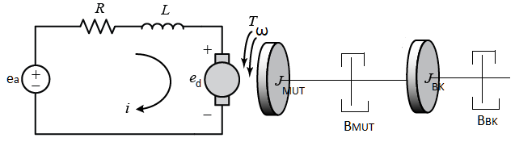

Figure 1: DC Brush Motor Electro-mechanical model

The electro-mechanical model of a DC brush motor is shown in **figure 1**. The electrical circuit takes an input voltage and generates a voltage drop $e_{d}$ across the rotor. The electrical energy from the voltage drop can be related to the resulting angular velocity, $ω$, through the motor velocity constant, $K_{e}$:

(Equation 1)

$$e_{d}=K_{e}ω$$

The current of the circuit, $i$, can also be coupled to the resulting torque in the motor, $T$, through the back-EMF constant, $K_{t}$:

(Equation 2)

$$T=K_{t}i$$

Performing electrical and mechanical analysis on the system using equations 1 and 2 leads to the following transfer function relating the output angular velocity to the input voltage:

(Equation 3)

$$G_{motor}\left(s\right)=\frac{Ω}{E_{a}}=\frac{K_{t}}{JRs+BR+K_{t}K_{e}}$$

Equation 3 is typically written in the following format for ease of identifying the system parameters, system gain, $K$, and time constant, $τ$:

$$G_{motor}\left(s\right)=\frac{Ω}{E_{a}}=\frac{K}{τs+1}=\frac{\frac{K_{t}}{BR+K_{t}K_{e}}}{\frac{JR}{BR+K_{t}K_{e}}s+1}$$

Therefore, the equations for the system gain and time constant of a motor are:

(Equation 5)

(Equation 4)

$$K=\frac{K_{t}}{BR+K_{t}K_{e}}$$

$$τ=\frac{JR}{BR+K_{t}K_{e}}$$

The detailed derivation steps for the motor transfer function are attached in Appendix A1.1 in this document.



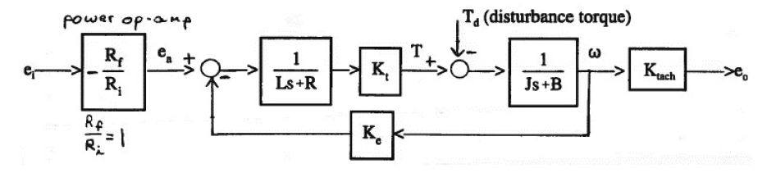

Transfer function with disturbance torque:

$$\left(\left(e_{a}-K_{e}ω\right)\left(\frac{1}{Ls+R}\right)K_{t}-T_{d}\right)\left(\frac{1}{Js+B}\right)=ω$$

Relating output to disturbance torque:

$$\frac{ω}{T_{d}}=-\frac{1}{[\left(Js+B\right)+\frac{K_{e}K_{t}}{\left(Ls+R\right)}]}$$